The Tacit Project: An Arduino-based sonar feedback device for the blind
Saturday, August 20th, 2011
Steve Hoefer from Grathio Labs has developed the Tacit project, basically an assistance device for sonar obstacle avoidance with haptic feedback. The device can measure the distance to objects and translate that into pressure on the wrist. It is based on our favorite Arduino Mini Pro.
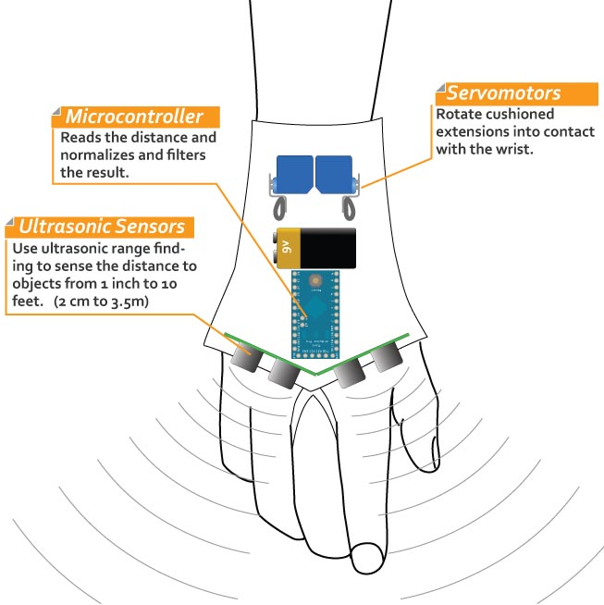
According to Steve, it’s wrist mounted and senses objects from about 1 inch (2 cm) to 10 feet (3.5m). It has generally fast response time (fractions of a second) to quickly navigate complex environments. It’s designed to help a vision impaired person to navigate complex environments. Mounted to the back of the hand, the force feedback means it doesn’t interfere with other assistance devices that mount elsewhere and use audio feedback cues.
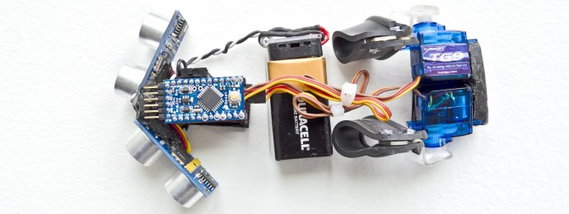
Steve shares in his post all the information on how to build it (parts and schematics) and the Arduino code as well. Great work and beautiful design Steve!
Referencia: http://medicarduino.net/?cat=14

Haptic Assisted Locating of Obstacles – H.A.L.O. using Arduino :-)
Tuesday, July 5th, 2011
Polymythic had the idea to develop a haptic feedback device for the visually impaired (Project H.A.L.O. as he has named it), that uses a series of rangefinders that would take input from sensors and output feedback to pulse vibration motors placed on a person’s head. As a person gets closer to an object the intensity and frequency of the vibration would increase – it’s directly proportional to the distance of an object. If a region was lacking feedback, then it would be safe to proceed in that direction.
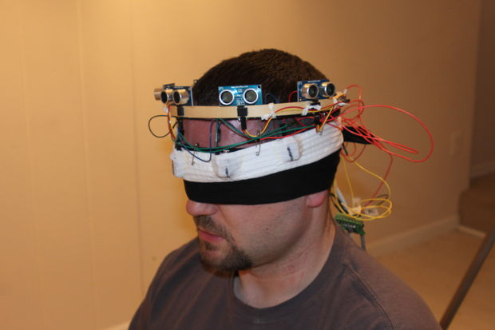

The main microcontroller for receiving the sensor feedback and generating the vibrations is Arduino Mega 2560.
More information and build instructions here!

